深圳大学考试答题纸
(以论文、报告等形式考核专用)
二○ 二二一 ～二○ 二 三 学年度第 一 学期
课程编号 | 1500430001 |  | 课序号 |  |  |  | 课程名称 |  | 专业英语 |  | 主讲教师 | 刘凌 | 评分
学 号 | 2021150122 |  |  | 姓名 |  | 郑雨婷 |  | 专业年级
教师评语：
题目： |  | The three major technical areas of computer vision and their applications

The three major technical areas of computer vision and their applications

Abstract
Computer vision is a simulation of biological vision using computers and related equipment. Its main task is to process the collected pictures or videos to obtain three-dimensional information of the corresponding scene, just as humans and many other types of creatures do every day. A core goal of computer vision is to understand images, which means to extract meaningful semantic information from pixels (such as the objects in the image and their location and number). This general problem can be divided into several sub-areas, which roughly include image classification, object recognition, object detection and localization, object and instance segmentation, and pose estimation [1]. In this paper, the three major technologies of image classification, object detection, and semantic segmentation are introduced and their usages.
- Introduction
Computer vision is difficult to define because it is at the intersection of several research and development fields, such as computer science (algorithms, data processing, and graphics), physics (optics and sensors), mathematics (calculus and information theory), and biology (visual stimulation and neural processing).
Essentially, computer vision can be summarized as the automatic extraction of information from digital images. When it comes to vision, our brains do wonders. Our ability to decipher the visual stimuli that the eye constantly picks, to instantly distinguish one object from another, to recognize the face of someone who has only seen one side, and so on, is incredible. To a computer, an image is just a block of pixels, a matrix of red, green and blue values, and has no other meaning.
Image classification, object detection, and semantic segmentation are the three major technologies in computer vision. [2] Object classification is the division of images into individual categories, usually corresponding to the most prominent objects in the image. But many real-world images often contain more than just an object, and assigning a single label to an image using an image classification model is actually very crude and inaccurate. For such cases, an object detection model is needed, which can recognize multiple objects in one picture and can locate different objects (giving bounding boxes). Object detection is useful in many scenarios, such as driverless driving and security systems. Semantic segmentation is an extension of background separation, requiring the separation of image parts with different semantics, which gives meaning to each pixel category (instance), which is suitable for scenarios with high understanding requirements, such as the segmentation of roads and non-roads in unmanned driving.
- Image Classification
2.1 What is image classification?
The image classification problem is when input an image, we should find a label from an existing collection of labels and assign it to the image. Here's an example [3]: Our image classification model reads this image and outputs the probability that this image corresponds to each label. For computers, images are made up of pixel information one by one. In this example, the image size of this cat is 248*400 pixels, because the picture is color, so it also contains three color channels of RGB. So that our input is 240*800*3=297600, and each number represents the brightness value of a channel. The range is between 0-255, with 0 representing white and 255 representing black. And all we have to do is get the computer to understand the digital information and then make a classification.
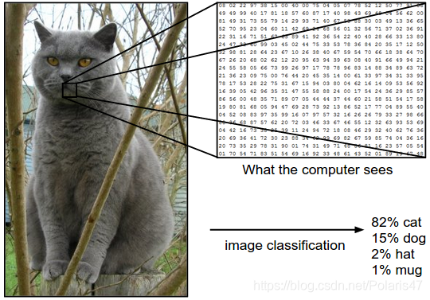
Figure 1. image classification model [1]
Image classification is essentially the task of assigning corresponding labels to images from a given collection of categories. That is, our task is to analyze an input image and return a label for that image category.
Assuming that the category set is {dog, cat, panda}, we provide an image to the classification model, as shown in figure 2 :
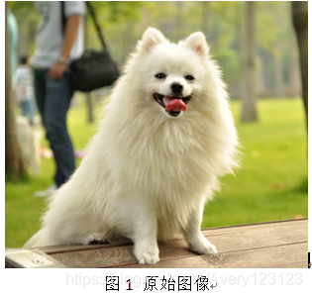
Figure 2. Original image
The classification model assigns multiple labels to the image, and the probability value of each label is different, such as dog:95%, cat:4%, panda:1%, and classifies the picture as dog according to the size of the probability value, which completes the task of image classification.
2.2 Traditional image classification algorithms
Generally, the complete establishment of image recognition models generally includes several stages such as underlying feature learning, feature coding, spatial constraints, classifier design, and model fusion, as shown in Figure 3[4].
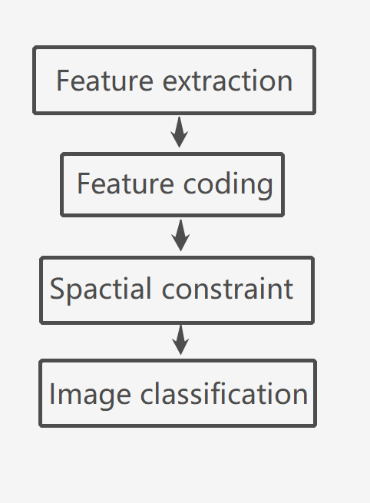
Figure 3. Traditional image classification process[4]
1). Underlying feature extraction: A large number of local feature descriptions are usually extracted from images according to fixed steps and scales. Commonly used local features include SIFT (Scale-Invariant Feature Transform), HOG (Histogram of Oriented Gradient), LBP (Local Bianray Pattern), etc., generally using a variety of feature descriptions to prevent the loss of too much useful information.
2). Feature coding: The underlying features contain a lot of redundancy and noise, in order to improve the robustness of feature expression, a feature transformation algorithm is needed to encode the underlying features, called feature coding. Commonly used feature coding methods include vector quantization coding, sparse coding, local linear constraint coding, Fisher vector coding, etc.
3). Spatial feature constraints: After feature coding, it will generally go through spatial feature constraints, also known as feature convergence. Feature aggregation means that in a spatial range, the maximum or average value of each dimensional feature can be taken to obtain the feature expression without deformation of certain features. Pyramid feature matching is a commonly used feature aggregation method, which proposes to evenly divide the image into blocks and do feature aggregation in the tiles.
4). Classification by classifier: After the previous steps, an image can be described by a fixed-dimensional vector, and then the image is classified by the classifier. Commonly used classifiers include SVM (Support Vector Machine), random forest, etc. SVMs using the kernel method are the most widely used classifiers and perform well in traditional image classification tasks.
This traditional image classification method is widely used in image classification algorithms in PASCAL VOC competitions.
2.3 Image classification applications
Image classification and detection are widely used in many fields, including face recognition, pedestrian detection, intelligent video analysis, pedestrian tracking, etc. in the security field, traffic scene object recognition, vehicle counting, wrong-way detection, license plate detection and recognition in the traffic field, and content-based image retrieval and automatic classification of albums in the Internet field.[5]
- Object Detection
3.1 What is object detection?
The task of object detection is to find out all the objects of interest in the image, determine their class and location, and is one of the core problems in the field of computer vision. Due to the different appearance, shape and attitude of various objects, coupled with the interference of lighting, occlusion and other factors during imaging, object detection has always been the most challenging problem in the field of computer vision.[6]
3.2 Object detection method classification
Object detection algorithms are mainly divided into two categories: two-stage and one-stage[7]:
Two-stage algorithm:
The algorithm first generates a series of candidate boxes as samples, and then the sample is classified by the convolutional neural network. As shown in the figure below, the object detection process is mainly completed through a convolutional neural network, which extracts CNN convolution features and performs two parts: candidate region screening and object detection. The network is highly accurate and relatively slow.
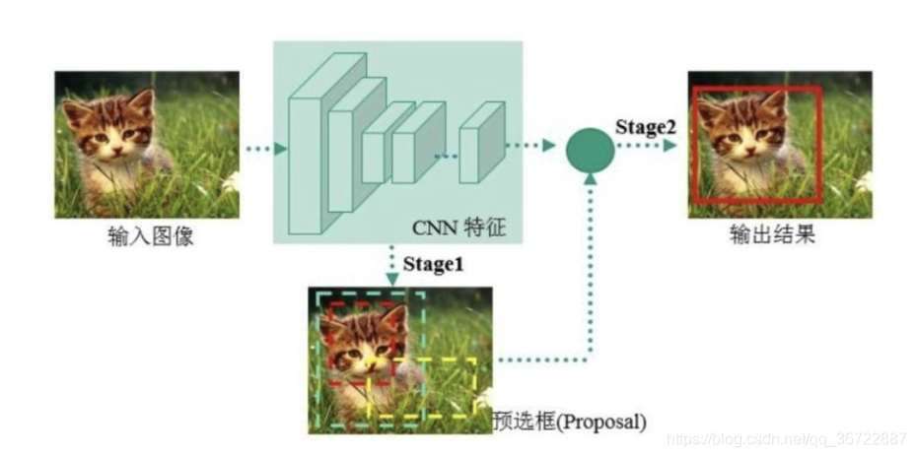
Figure 4. Two-stage algorithm
The two-stages algorithm is represented by the RCNN series: R-CNN to Faster R-CNN networks
One-stage algorithm:
The category and location information of the target is given directly through the backbone network, without using the screening network of the candidate area, this algorithm is fast, but the accuracy is much lower than that of the Two-stage target detection network.
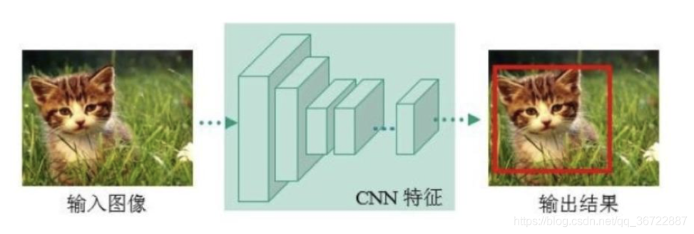
Figure 5. One-stage algorithm
The representatives of the one-stage algorithm are: YOLO series: YOLOv1, YOLOv2, YOLOv3, SSD, etc.
3.2 Typical application scenarios of object detection
Object detection is one of the most basic problems of computer vision and has a wide range of applications, and the following briefly introduces a few typical application scenarios [8].
1. Face recognition
Face recognition is a biometric technology based on human facial features for identification, which automatically detects and tracks faces by collecting images or video streams containing faces, and then recognizes the detected faces, usually also known as portrait recognition and facial recognition.
The face recognition system mainly includes four parts, namely face image acquisition/detection, face image preprocessing, face image feature extraction, and identity matching and recognition. Among them, face image acquisition/detection is the basis for subsequent recognition. As shown in Figure 6, the processing area of the subsequent recognition algorithm is limited from the entire image to the face area by the detection frame.
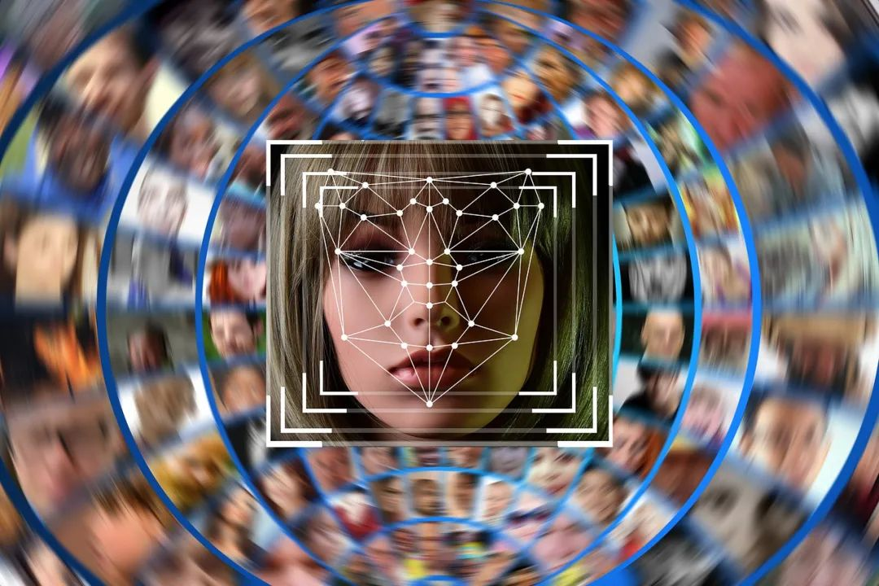
Figure 6. Face recognition example
In recent years, face recognition technology has made great progress, and is now widely used in many practical scenarios such as public security, transportation, and payment.
2. Smart transportation
Intelligent transportation is an important application field of object detection, mainly including the following scenarios.
Traffic flow monitoring and traffic light timing control: Through visual algorithms, the video images collected in road bayonet cameras and electric police cameras are analyzed, and traffic light timing strategies are adjusted according to the traffic flow of the corresponding road section to improve traffic capacity.
Abnormal event detection: Through visual algorithms, detect various traffic abnormal events, including non-motor vehicles driving into motor lanes, vehicles occupying emergency lanes, monitoring the driving behavior of drivers of dangerous goods transport vehicles, real-time alarm of traffic accidents, etc., and report abnormal events to the traffic management department at the first time.
Traffic violation detection and tracking: Through visual algorithms, the phenomenon of evasion of decked vehicles and toll booths is discovered, the vehicles involved in accidents are tracked, and the trajectory of suspicious vehicles/pedestrians is tracked throughout the process, and the supervision capabilities of public security/traffic management departments are greatly improved through visual technical means.
Autonomous driving: Autonomous driving is a hot research field today, and it is a research direction with a high degree of intersection of a variety of cutting-edge technologies, among which vision-related algorithms mainly include the detection of roads, vehicles and pedestrians, and the detection and recognition of traffic signs and roadside objects. Mainstream artificial intelligence companies have invested a lot of resources in the research and development of autonomous driving, and have initially realized automatic driving under restricted road conditions, but there is still a considerable distance from realizing automatic driving (L4 level) that is not affected by road conditions, weather and other factors.
Fundamentally, the underlying implementation of various specific applications in traffic scenarios is based on object detection technology, that is, the detection of roads, vehicles and pedestrians.
3. Industrial testing
Industrial inspection is another important application area for computer vision, which is widely used in various industries. In the production process of products, due to the influence of raw materials, manufacturing processes, environmental and other factors, products may cause various problems. A considerable part of these are so-called cosmetic defects, i.e. defects that are recognizable to the human eye.
Figure 7 is a schematic diagram of the core board break in the inner layer of the circuit board, and it is obvious that there is a broken part of the copper wire in the figure.
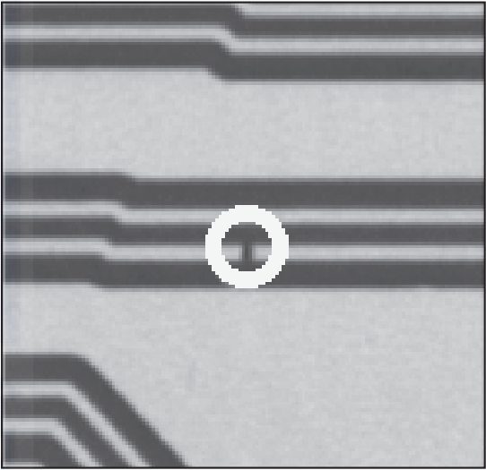
Figure 7. Schematic diagram of the core board break in the inner layer of the circuit board
In the traditional production process, most of the appearance defects are identified by manual inspection, which not only consumes labor costs, but also cannot guarantee the detection effect. Industrial detection is to use the object detection algorithm in computer vision technology to detect cracks, deformations, parts loss and other appearance defects in the production process of products, so as to improve product quality stability and improve production efficiency.
- semantic segmentation
4.1 What is semantic segmentation?
Image semantic segmentation, literally speaking, is to let the computer segment according to the semantics of the image, such as allowing the computer to output the right image when entering the left image below. Semantics in speech recognition refers to the meaning of speech, in the field of images, semantics refers to the content of images, the understanding of the meaning of pictures, such as the semantics of the left picture is three people riding three bicycles; Segmentation means to divide different objects in the picture from the perspective of pixels, and label each pixel in the original image, such as pink for people and green for bicycles in figure 8 [9].
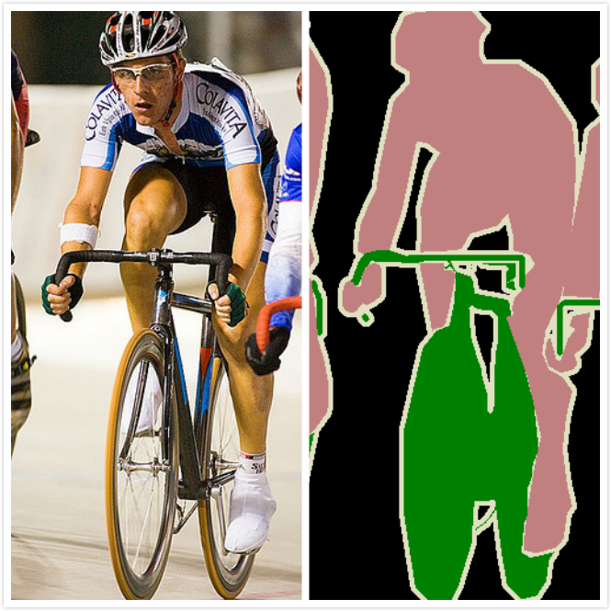
Figure 8. semantic segmentation [9]
4.2 Semantic segmentation typical application scenarios
At present, the application fields of semantic segmentation mainly include:
Geographic information system can train a neural network to let the machine input satellite remote sensing images, automatically identify roads, rivers, crops, buildings, etc., and label each pixel in the image. (The left side of the figure below is a satellite remote sensing image, the middle is the real label, and the right is the label result predicted by the neural network, as you can see, as the training deepens, the prediction accuracy continues to improve.) Training using ResNet FCN networks).
Unmanned vehicle driving, semantic segmentation is also the core algorithm technology of unmanned vehicle driving, on-board cameras, or lidar to detect the image and input into the neural network, the background computer can automatically segment and classify the image to avoid pedestrians and vehicles and other obstacles.
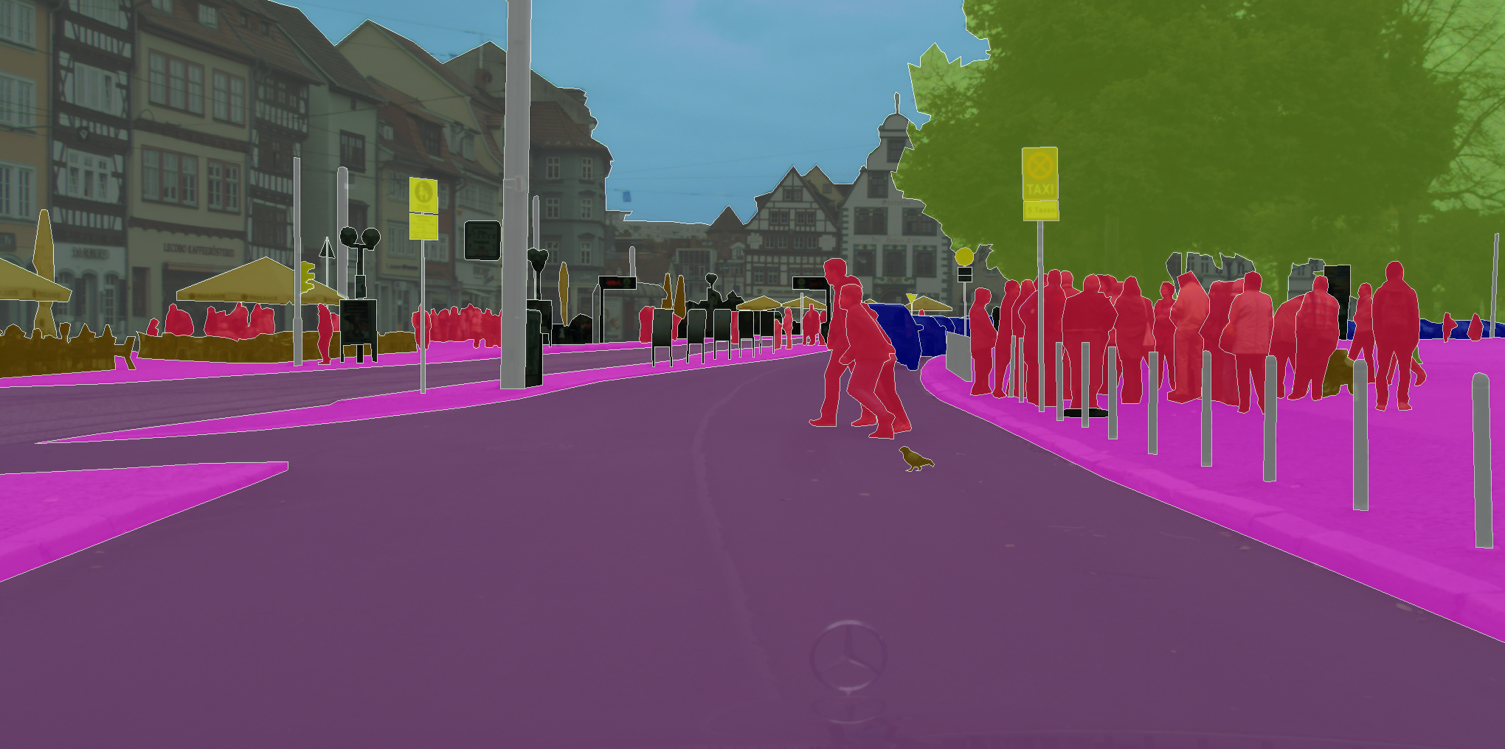
Figure 9. Unmanned vehicle driving
Medical image analysis, with the rise of artificial intelligence, the combination of neural networks and medical diagnosis has also become a research hotspot, and intelligent medical research has gradually matured. In the field of intelligent medical care, semantic segmentation is mainly used in tumor image segmentation, dental caries diagnosis, etc. (The picture below shows dental caries diagnosis, head CT scan emergency care diagnostic assistant and lung cancer diagnosis assistant)
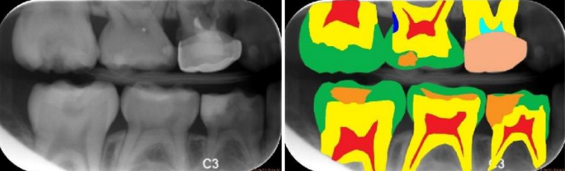
Figure 10. Diagnosis of dental caries
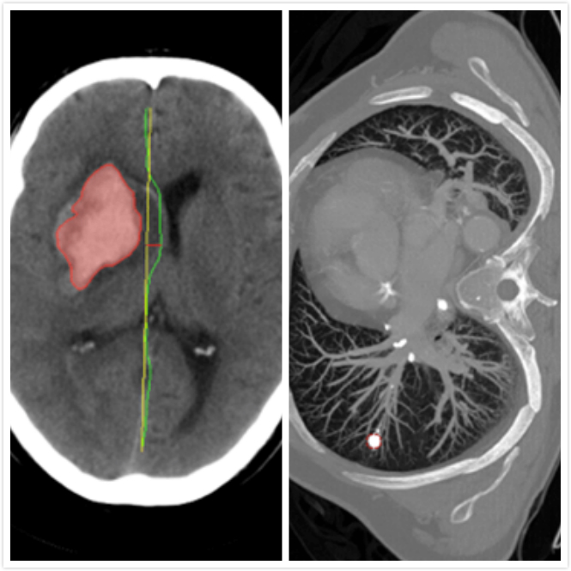
Figure 11.Head CT scan, emergency nursing diagnostic aid, and lung cancer diagnostic aid
- Conclusions
In this paper, we examine three major techniques in computer vision: image classification, object detection, and semantic segmentation, and explain what applications they are applicable to. Image classification (Classification) is to structure the image into a certain category of information, and use a predetermined category (category) or instance ID to describe the picture. If the image contains multiple objects, you can use an object detection algorithm. Segmentation is a pixel-level description of an image, which gives meaning to each pixel category (instance) and is suitable for understanding demanding scenarios, such as the segmentation of road and non-road in autonomous driving.
References
- 计算机视觉介绍（非常详细）. [Online]. Available:
http://c.biancheng.net/view/2n6goj.html
[2] 计算机视觉领域的三大任务. [Online]. Available:
https://www.cnblogs.com/zhaopengpeng/p/12268404.html
[3] （一）图像分类. [Online]. Available:
https://blog.csdn.net/Polaris47/article/details/84403642
[4] 计算机视觉-----图像分类综述. [Online]. Available:
https://blog.csdn.net/Avery123123/article/details/106769742
[5] 机器视觉图像物体分类与检测技术概述. [Online]. Available:
https://www.sohu.com/a/243161415_100166336
[6] 目标检测概述. [Online]. Available:
https://blog.csdn.net/weixin_46556352/article/details/124168613
[7] 【详解】计算机视觉之目标检测. [Online]. Available:
https://blog.csdn.net/qq_36722887/article/details/118186918
[8] 计算机视觉目标检测可以用在哪里？[Online]. Available:
https://blog.csdn.net/gu1857035894/article/details/125484851
[9] 计算机视觉之语义分割. [Online]. Available:
https://blog.geohey.com/ji-suan-ji-shi-jue-zhi-yu-yi-fen-ge/

